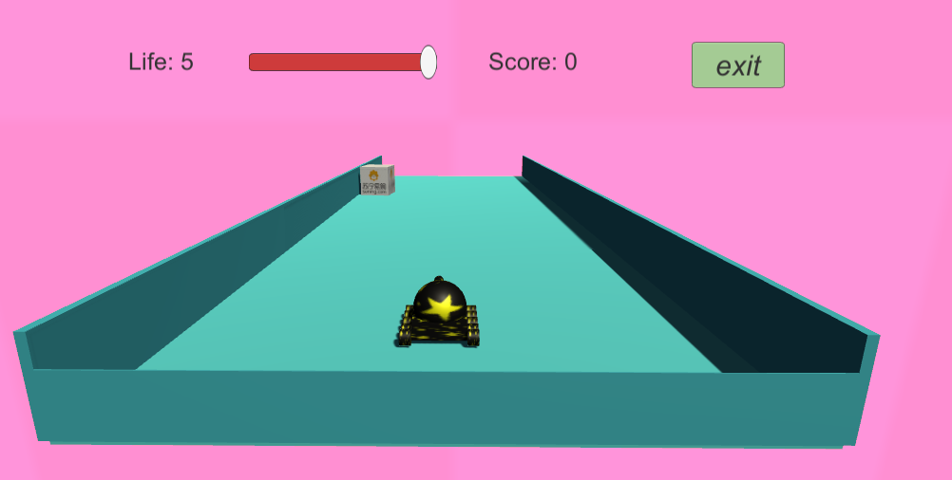

**Unity3D Game design final project**

Project name : Tank and Box

Class：EC1

Student:

Name：Sophie student number：201619010109

目录

Unity3D Game design final project 2

INTRODUCTION 2

CONTENT 2

start scene 2

Menu scene 8

Running01 scene 11

Win scene 23

Lost scene 27

RESULTS 30

CONCLUSIONS 32

Unity3D Game design final project

## INTRODUCTION

It should contain brief information about the Final Project experience.

* Create Game object in scene
* Using UI Controls in scence ( Canvas, Image,Text ,Slider)
* Using transform.Translate ( ) to move object.
* Use SceneManager.LoadScene() to switch scene
* Add Audio Source
* Using prefabs to create game object in running time
* Using Destroy() to destroy game object in running time
* Using OnCollisionEnter to check collision of game object

## CONTENT

Lab process including:

* Lab steps.
* Screenshots
* C# Code(if required is in the report instructions)
* Unity configurations for the lab.

### start scene

#### Overview

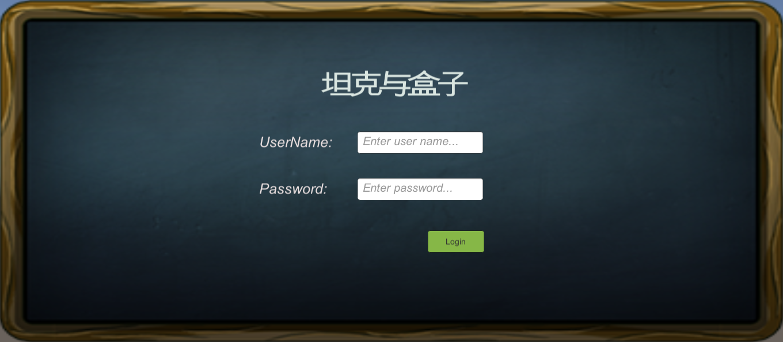

#### Detail

##### 1.create a canvas and name it “Login”, then add “RawImage” as the background ,add “Text” rename it title , add “Text” name it “UserNameText”, add “Input Field” name it “UserNameInputField”, copy the “UserNameText” and “UserNameInputField” then rename they to “PassWordText” and “PassWordInputField” ,add “button” name it “LoginButton”, add “Text” name it “error” ,adjust their position :

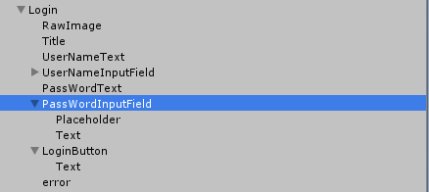

##### 2.loading picture resource

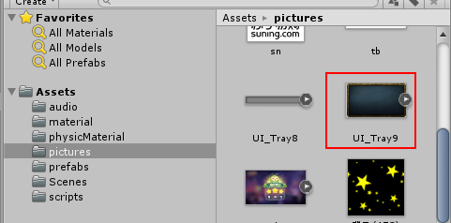

##### 3.selected UI_Tray9 , go to inspector , set the Texture Type to “Sprite(2D and UI)”

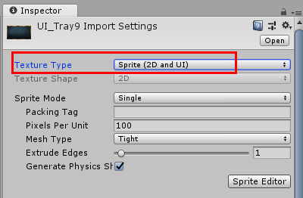

##### 4.selectetd “RawImage” , and set the Texture to “UI_Tray9”:

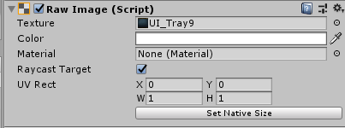

##### 5.create Empty object ,C# file name it “LoginEvent”,

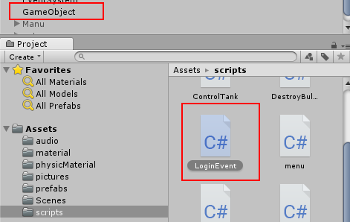

##### 6. write code in “LoginEvent” :

|  |
| --- |
| using System.Collections;  using System.Collections.Generic;  using UnityEngine;  using UnityEngine.UI;  using UnityEngine.SceneManagement;  public class LoginEvent : MonoBehaviour {  public InputField Username;  public InputField Password;  public GameObject Manu;  public GameObject Note;  public Text error;  private AudioSource audioSource;    // Use this for initialization  void Start () {  //获取音频组件  audioSource = GetComponent<AudioSource>();  }  public void GotoNote()  {  if (Username.text == "sophie" && Password.text == "123456")  {  //显示说明  Note.gameObject.SetActive(true);  //播放音乐  audioSource.Play();  }  else  {  //InputAgain.gameObject.SetActive(true);  error.text = "用户名或密码错误，请重新输入";  }    }  public void GotoMenu()  {  //显示菜单  SceneManager.LoadScene("menu");    }  public void GameLevel01(string SceneName)  {  SceneManager.LoadScene(SceneName);  }  public void GameExit()  {  Application.Quit();  }  // Update is called once per frame  void Update () {    }  } |

Attach the “LoginEvent” to GameObject, and drag the object to script varable:

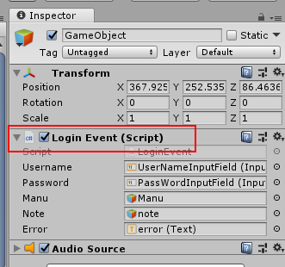

##### 7、selected “LoginButton” ,and add on click event:

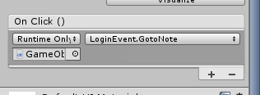

##### 8.create canvas and name it “note”, add follow components:

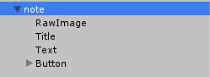

Adjust the view like this:

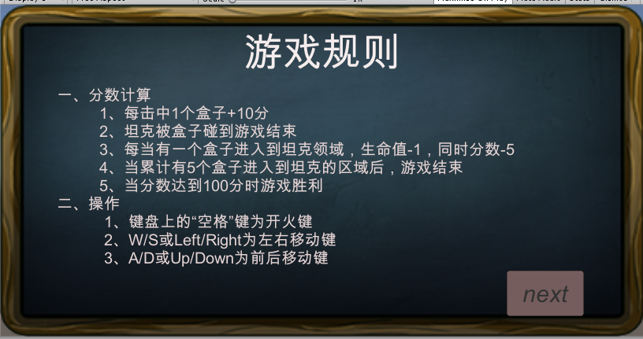

selected “Button” ,and add on click event:

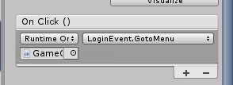

##### 9:click play to test, the result :

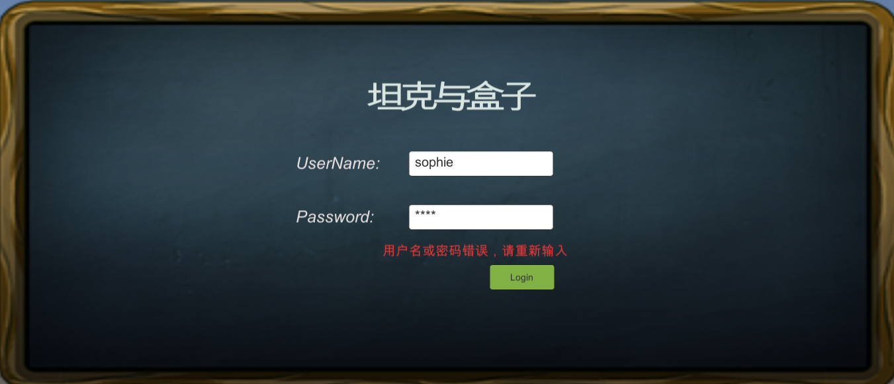

### Menu scene

#### Overview

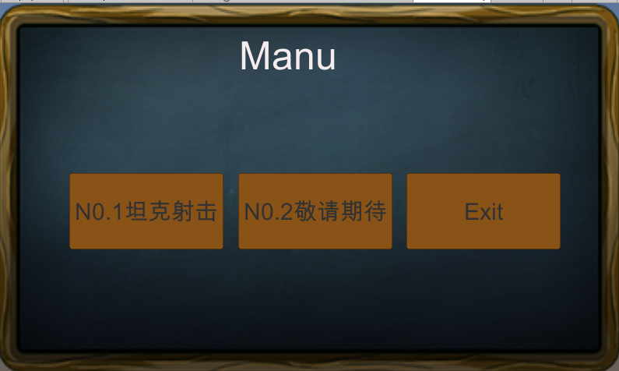

#### Detail

##### create a canvas ,and name it “menu” , add one “RawImage” as background ,add “Text” name it “Title” ,add three “button” and name they “ level01” ,”level02” , “exit”

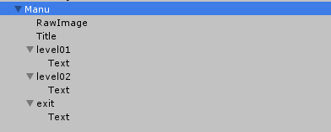

##### 2. selectetd “RawImage” , and set the Texture to “UI_Tray9”:

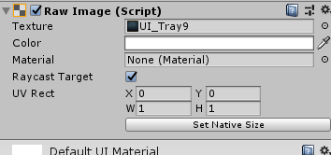

##### 3.create empty object “GameObject” , Attach the “LoginEvent” C# script to GameObject:

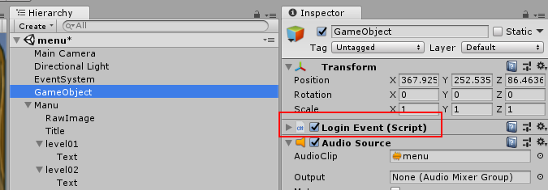

Selected “level01” set on click event

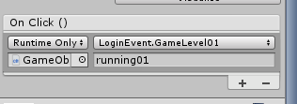

Selected “exit” set on click event

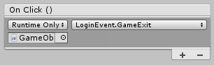

4.Add “Audio Source” component in “GameObject” and attach “menu.mp3” to AudioClip:

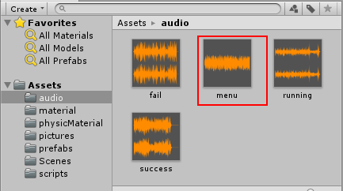

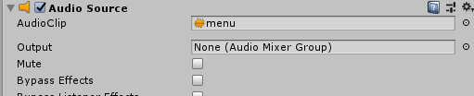

### Running01 scene

#### Overview

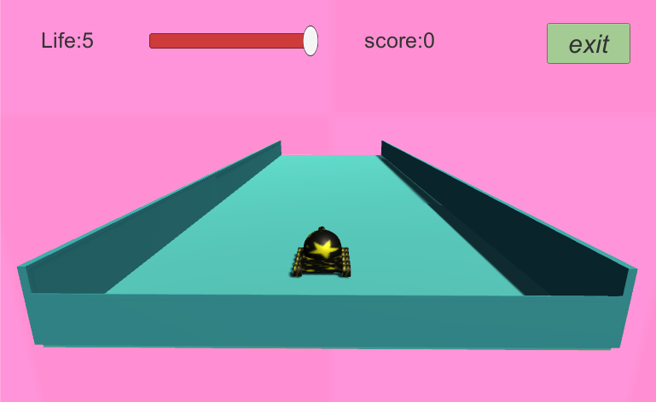

#### Detail

##### create a cube and name it “floor” :

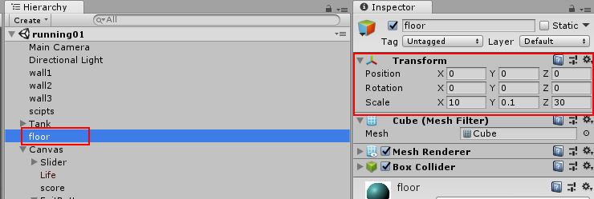

##### 2.create three cube name they “wall1”,”wall2”,”wall3”:

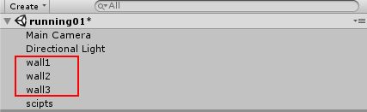

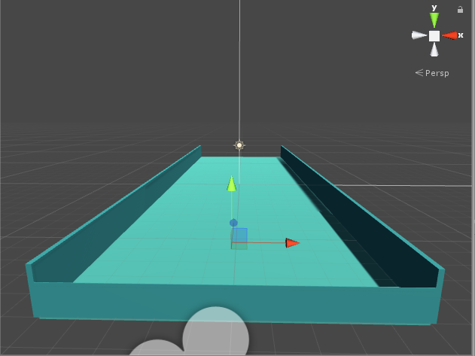

##### 3.create empty object and name it “tank” , then add follow object:

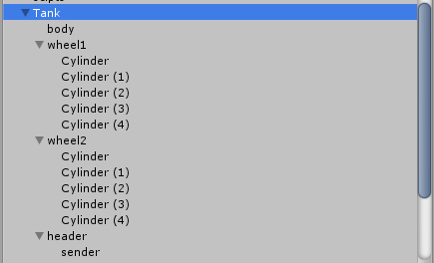

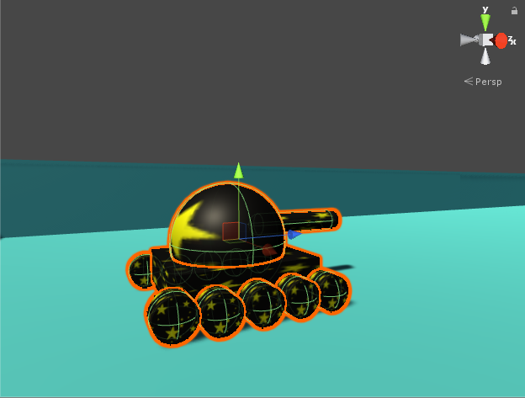

##### 4.create prefabs as following:

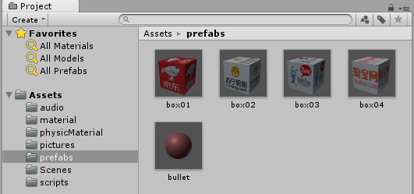

And create two C# file name they “BoxEevent” ,”DestroyBullet” ,and attach they to box , bullet prefabs:

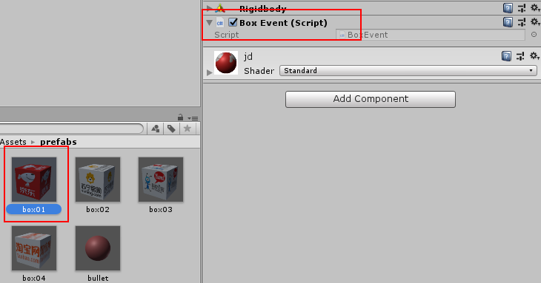

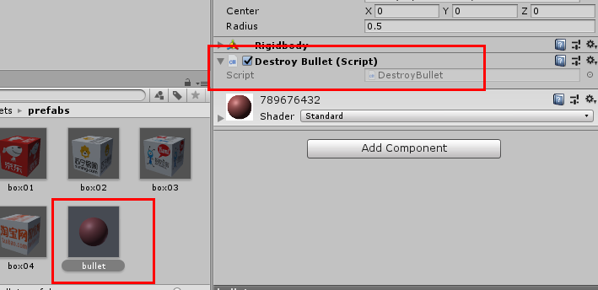

BoxEevent.cs

|  |
| --- |
| using System.Collections;  using System.Collections.Generic;  using UnityEngine;  using UnityEngine.UI;  using UnityEngine.SceneManagement;  public class BoxEvent : MonoBehaviour {  //分数  public static float Score = 0;  //生命值  public static float Life = 5;  // Use this for initialization  void Start()  {    }  // Update is called once per frame  void Update()  {  if (Score == 100)  {  print("you win");  PlayerPrefs.SetFloat("Score", 0);  PlayerPrefs.SetFloat("Life", 5);  Score = 0;  Life = 5;  SceneManager.LoadScene("win");  }  if (Life <= 0)  {  print("game over");  PlayerPrefs.SetFloat("Score", 0);  PlayerPrefs.SetFloat("Life", 5);  Score = 0;  Life = 5;  SceneManager.LoadScene("lost");  }  }  private void OnCollisionEnter(Collision collision)  {  if (collision.gameObject.tag == "tank")  {  //坦克被盒子碰到了，游戏结束  SceneManager.LoadScene("lost");  PlayerPrefs.SetFloat("Score", 0);  PlayerPrefs.SetFloat("Life", 5);  Score = 0;  Life = 5;  }  else  {  if (collision.gameObject.tag == "bullet")  {  Destroy(collision.gameObject);  Destroy(this.gameObject);  //坦克被盒子碰到了，+10分  Score += 10;  //将分数缓存  PlayerPrefs.SetFloat("Score", Score);  }  if (collision.gameObject.tag == "wall")  {  Destroy(this.gameObject);  //让盒子进入到禁地了扣5分，同时生命值-1  Score -= 5;  Life -= 1;  //将分数缓存  PlayerPrefs.SetFloat("Score", Score);  PlayerPrefs.SetFloat("Life", Life);  }  }  }    } |

DestroyBullet.cs:

|  |
| --- |
| using System.Collections;  using System.Collections.Generic;  using UnityEngine;  public class DestroyBullet : MonoBehaviour {  // Use this for initialization  void Start () {    }    // Update is called once per frame  void Update () {  if(transform.position.y < 0)  {  Destroy(this.gameObject);  }    }  } |

##### 5.create empty object name it “scripts”, and create three C# file and attach they to scripts as following:

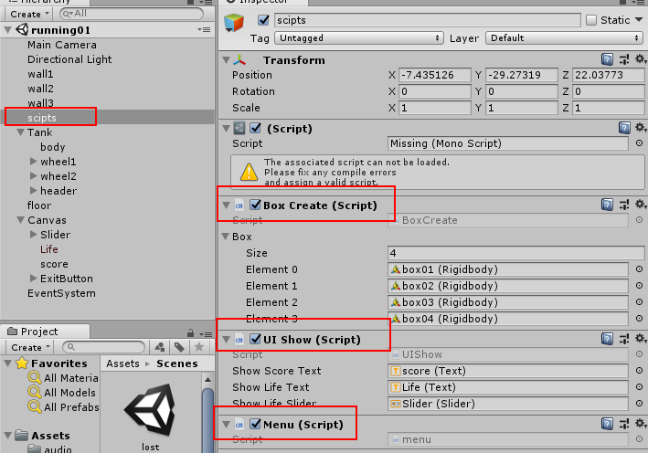

BoxCreate .cs:

|  |
| --- |
| using System.Collections;  using System.Collections.Generic;  using UnityEngine;  public class BoxCreate : MonoBehaviour {  public Rigidbody[] Box;  private Rigidbody box;  // Use this for initialization  void Start () {  InvokeRepeating("CreateBox", 1, 3);  }    // Update is called once per frame  void Update () {  }  void CreateBox()  {  float x = Random.Range(-4,4);  int i = Random.Range(0, 3);  box = Instantiate(Box[i]);  box.transform.position = new Vector3(x,0.75f,10);  box.AddForce(new Vector3(0, 0, -1) * 10, ForceMode.Impulse);  }  } |

UIShow.cs

|  |
| --- |
| using System.Collections;  using System.Collections.Generic;  using UnityEngine;  using UnityEngine.UI;  using UnityEngine.SceneManagement;  public class UIShow : MonoBehaviour {  public Text showScoreText;  public Text showLifeText;  public Slider showLifeSlider;    // Use this for initialization  void Start () {    }    // Update is called once per frame  void Update () {  float score = PlayerPrefs.GetFloat("Score");  float life = PlayerPrefs.GetFloat("Life");  showScoreText.text = "Score: "+ score;  showLifeText.text = "Life: "+life ;  showLifeSlider.value = life;  }  } |

Menu.cs

|  |
| --- |
| using System.Collections;  using System.Collections.Generic;  using UnityEngine;  using UnityEngine.UI;  using UnityEngine.SceneManagement;  public class menu : MonoBehaviour {  // Use this for initialization  void Start () {    }    // Update is called once per frame  void Update () {    }  public void ShowMenu()  {  SceneManager.LoadScene("menu");  }  public void GameAgain()  {  SceneManager.LoadScene("running01");  }  public void GameExit()  {  Application.Quit();  }  } |

##### 6.create a canvas and add follow components:

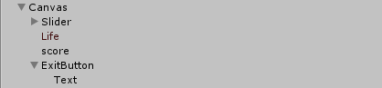

##### 7.Selected “ExitButton” ,and set on click event:

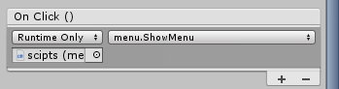

##### 8.Add “Audio Source” in “MainCamara” as following

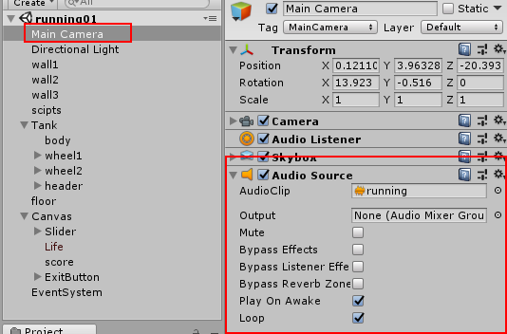

##### 9.create a C# file and name it “sendBullet” then attach the “Tank/header/sender” ,and attach prefab bullet to C# variable:

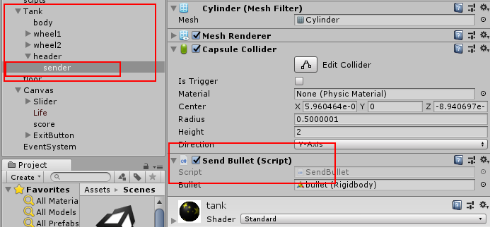

##### 10.create C# file name it “ControlTank” , and attach it to “Tank” object

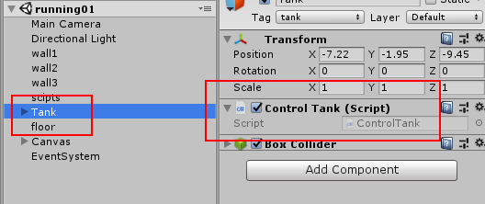

|  |
| --- |
| using System.Collections;  using System.Collections.Generic;  using UnityEngine;  public class ControlTank : MonoBehaviour {  private float speed = 5f;    // Use this for initialization  void Start () {    }    // Update is called once per frame  void Update () {    //判断坦克的位置，如果坦克处于可活动范围则激活移动键  //否则把坦克弹回可移动范围去  if (-11 < transform.position.x && transform.position.x < -3 && -12 < transform.position.z && transform.position.z < 8)  {    transform.Translate(Vector3.forward * Input.GetAxisRaw("Vertical") * speed * Time.deltaTime);    transform.Translate(Vector3.right * Input.GetAxisRaw("Horizontal") * speed * Time.deltaTime);  }  else if(-11 > transform.position.x)  {  transform.position += new Vector3(0.1f,0,0);  }  else if (transform.position.x > -3)  {  transform.position -= new Vector3(0.1f, 0, 0);  }  else if (-12 > transform.position.z)  {  transform.position += new Vector3( 0, 0,0.1f);  }  else if (transform.position.z > 8)  {  transform.position -= new Vector3(0, 0,0.1f);  }  }  } |

### Win scene

#### Overview

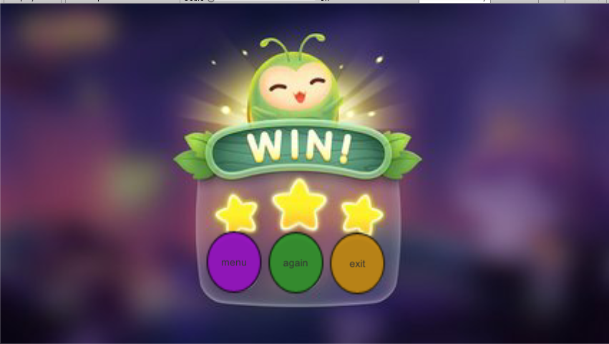

#### Detail

##### create a canvas add follow components:

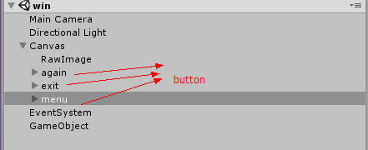

##### selectetd “RawImage” , and set the Texture to “lost”:

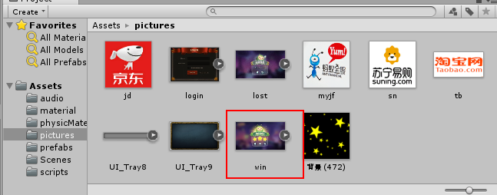

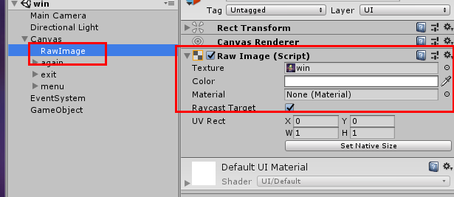

##### 3.Add “Audio source” component to “MainCamara”

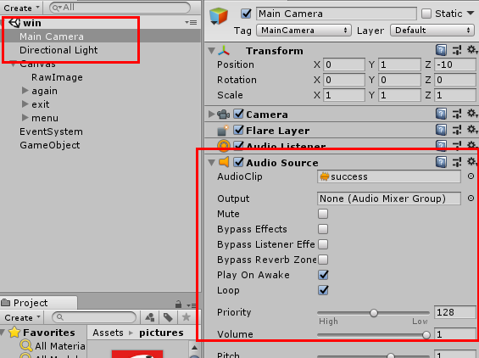

##### 4.create empty object “GameObject” and attach C# file “Menu”:

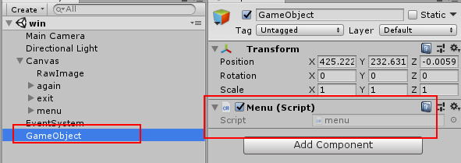

##### 5.Selected “again” button and set on click event:

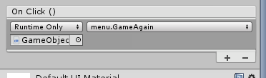

##### 6.Selected “exit” button and set on click event:

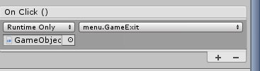

##### 7. Selected “menu” button and set on click event:

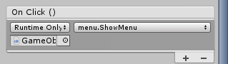

### Lost scene

#### Overview

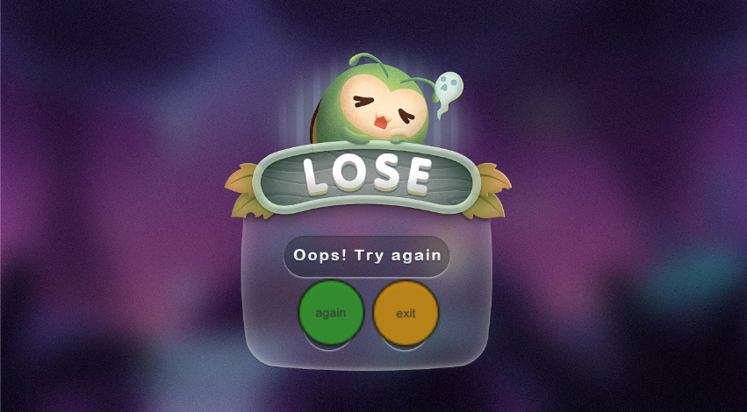

#### Detail

##### 1.create a canvas add follow components:

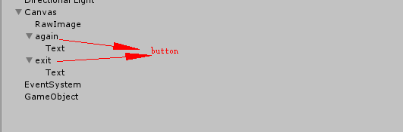

##### 2.selectetd “RawImage” , and set the Texture to “lost”:

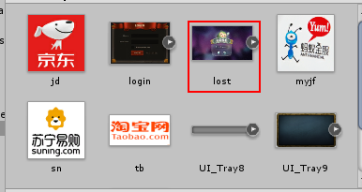

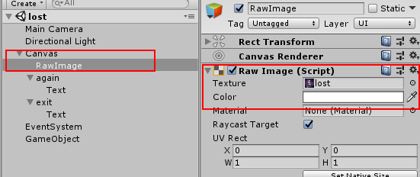

##### 3.Add “Audio source” component to “MainCamara”

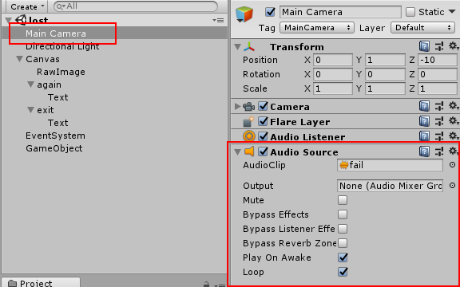

##### 4.create empty object “GameObject” and attach C# file “Menu”:

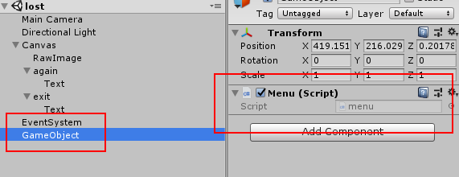

##### 5.Selected “again” button and set on click event:



##### 6.Selected “exit” button and set on click event:



## RESULTS

Include the results you got from the work in the lab, screenshots and explanation.

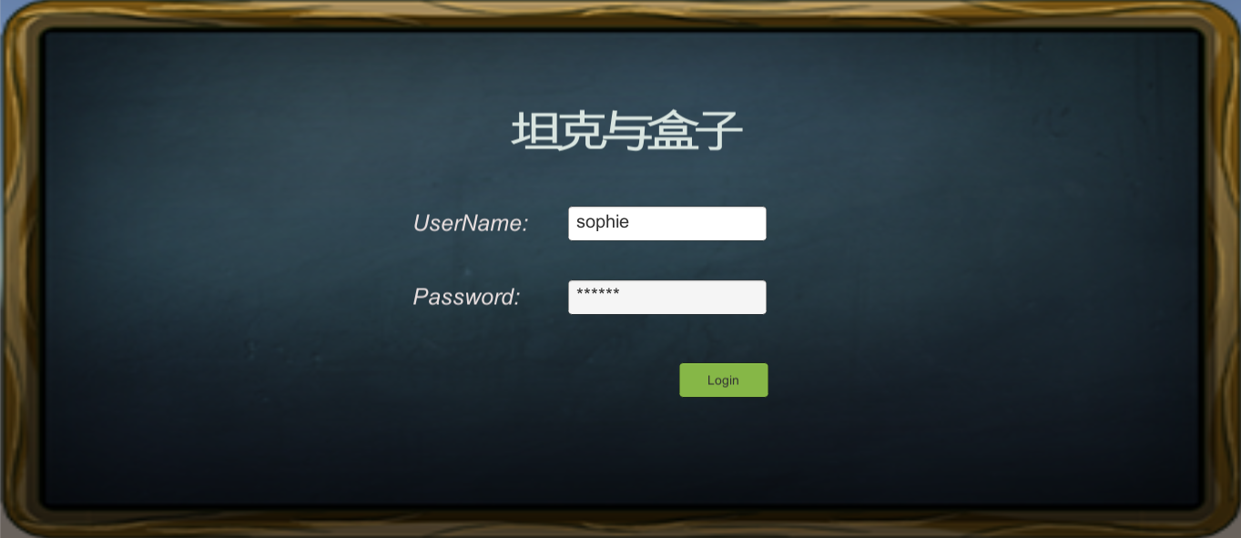

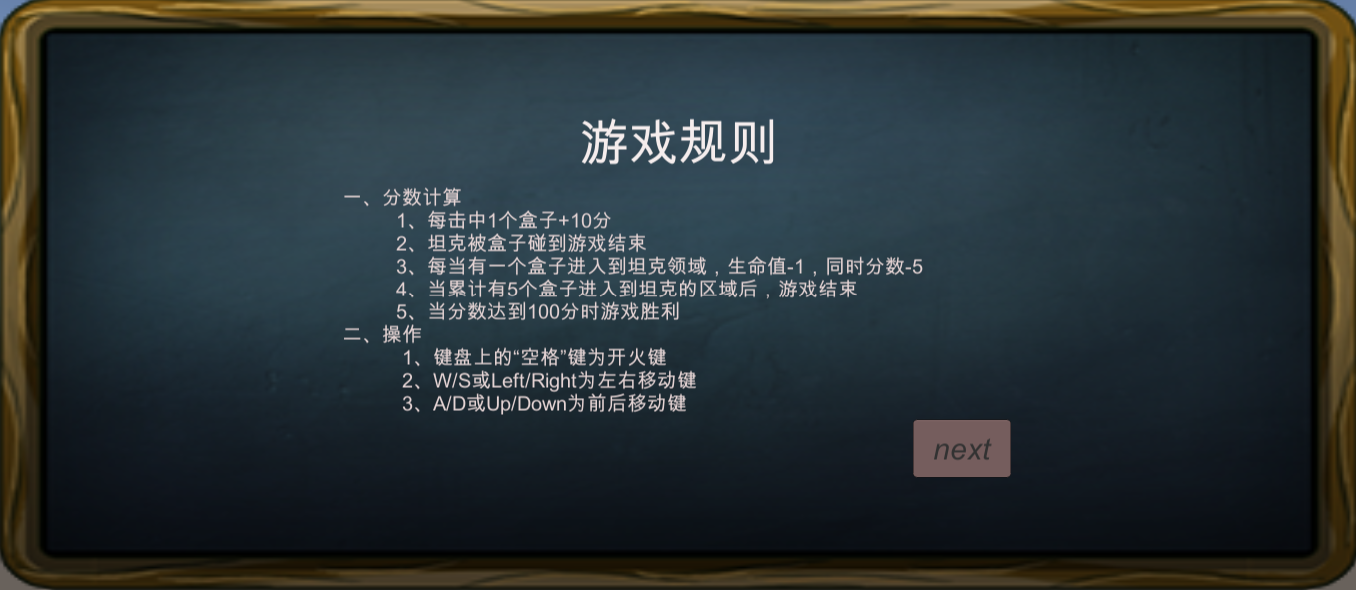

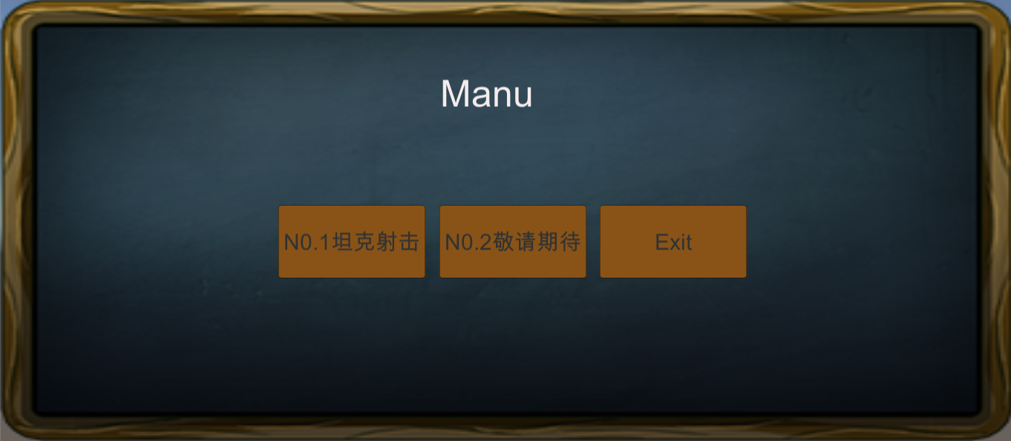

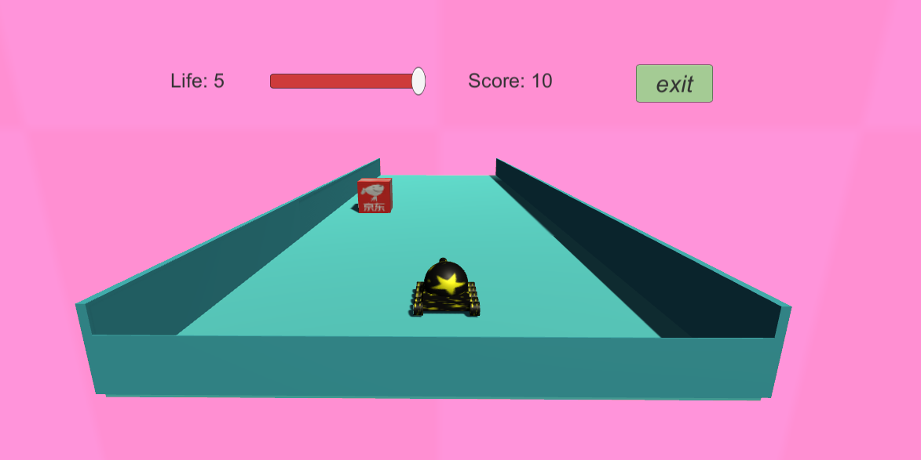

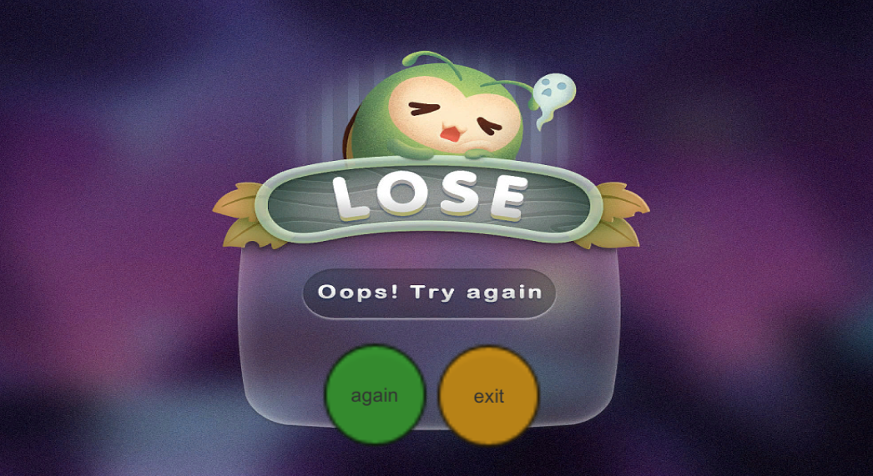

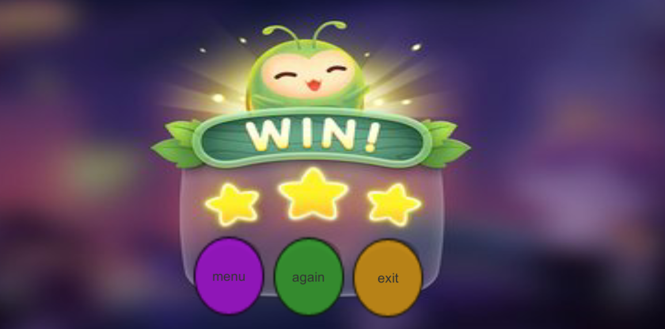

## CONCLUSIONS

* What did you learn?

In this Final project, I had obtained independently thinking and handing problems, and practice the knowledge points learned in this semester. Everything make by my hand, I feel proud.

* What was complicated? Why?

I think UI was complicated. It’s hard for me to find right material, and also, I don’t know how to use “Photoshop” to make fit picture.

* Did you have any inconvenient during the development of the lab?

Yes , the position of the game object is difficult to control.

* Describe how you would use what you learn in a game.

Like the INTRODUCTION said I use following knowledge to complete my game :

Create Game object in scene

Using UI Controls in scence ( Canvas, Image,Text ,Slider)

Using transform.Translate ( ) to move object.

Use SceneManager.LoadScene() to switch scene

Add Audio Source

Using prefabs to create game object in running time

Using Destroy() to destroy game object in running time

Using OnCollisionEnter to check collision of game object

* Write your conclusions of this Final Project.

One Game , its story and UI are very important. As a Game designer , you must need very rich imagination and patience to design game and code.